**SILICA SAND**

**HERO**



Silica sand is a durable and versatile material used in industries ranging from construction and glassmaking to oil and gas. Flexicon’s bulk material handling systems are built to move silica sand safely and efficiently through every phase of production, from unloading and conveying to storage and packaging.

**Button**: Talk To Us

**SHELF #1 - PRODUCT DESCRIPTION**

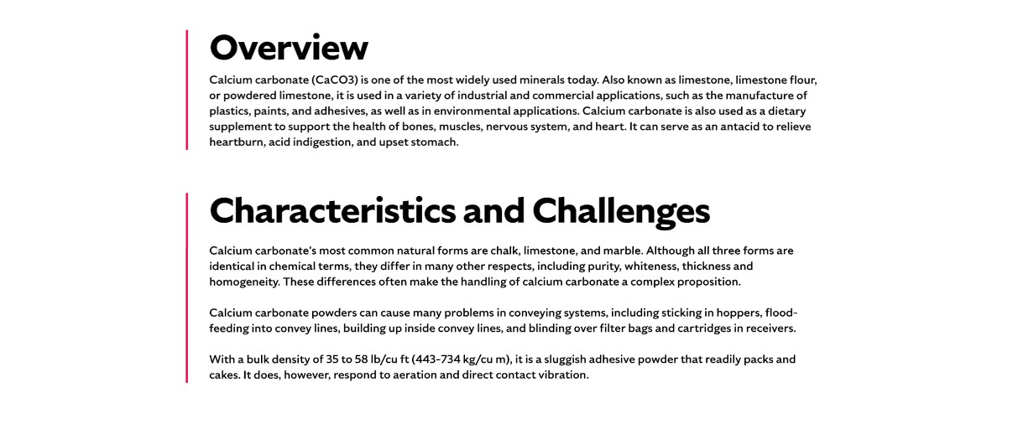

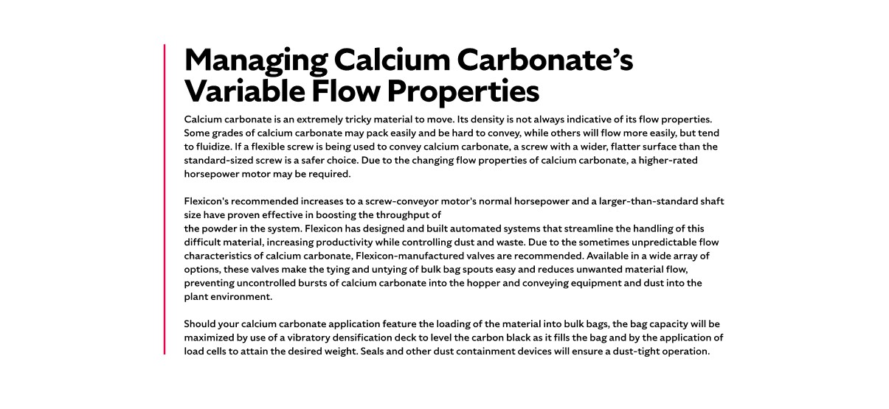

**Overview**

Silica sand, also known as quartz sand or industrial sand, is primarily composed of quartz crystals and is mined and processed into various grades for industrial use. Its applications range from glass manufacturing and metal polishing to hydraulic fracturing and water filtration. The physical and chemical properties of silica sand—such as grain hardness, purity, and particle size—determine its suitability for specific processes. Whether used in manufacturing or infrastructure, silica sand contributes essential qualities like strength, precision, and durability. The characteristics that influence silica sand’s performance include cleanliness (the proportion of silt, clay, and organic matter), color (with brown or orange tones indicating impurities such as iron oxides), grain size and shape, particle size distribution, and refractoriness (melting point).

**Characteristics and Challenges**

Silica sand’s abrasive nature demands rugged conveying systems that can withstand wear on internal surfaces and moving parts. With an average bulk density of 81 lbs/cu ft, it is generally free-flowing, but fine particles can damage sensitive components and pose health risks such as silicosis. Coarser grains may interlock and restrict flow, while improper air-line velocity during pneumatic conveying can degrade the material. Equipment must be carefully selected and sized to prevent damage, maintain product integrity, and ensure long-term system performance.

When silica sand arrives in bulk bags, discharge frames should include features like spring-loaded supports to stretch the bags and eliminate trapped material. Dust control is critical during dumping and de-gassing, with cartridge filters and reverse-pulse cleaners helping to contain and recycle dust. For smaller bags, a bag-breaking station with dust hoods, filtration, and hopper screens ensures safe, clean manual unloading. Flexible screw conveyors should use heavy-duty, round-profile screws to handle abrasion, and bulk bag fillers should include densification decks, load cells, and sealing systems for accurate, dust-tight filling.

.

**SHELF #2 - FLEXICON SOLUTIONS**

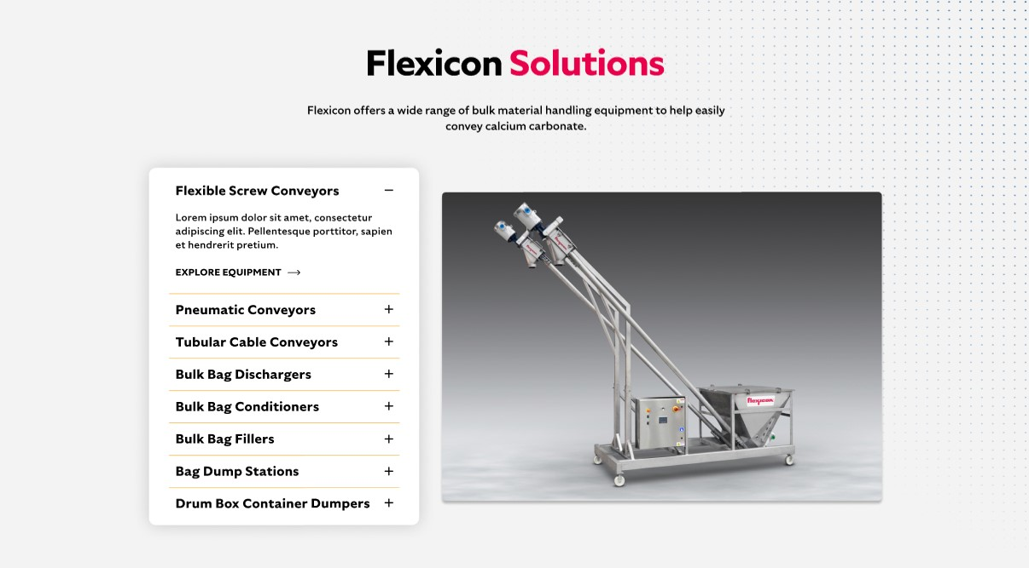

**Flexicon Solutions**

Flexicon offers a wide range of bulk material handling equipment to help easily convey silica sand.

**Flexible Screw Conveyors:** Designed with abrasion-resistant components, these conveyors reliably transport silica sand without clogging or degradation.

**Pneumatic Conveyors:** These fully enclosed systems move silica sand cleanly and efficiently, minimizing airborne dust and material loss.

**Tubular Cable Conveyors:** Ideal for tight layouts, these conveyors offer a sealed path that protects silica sand from contamination and spillage.

**Bulk Bag Dischargers:** Engineered for secure unloading, these systems prevent dust escape while ensuring complete discharge of silica sand.

**Bulk Bag Conditioners:** Break up hardened silica sand inside bulk bags to restore free-flowing consistency and improve downstream performance.

**Bulk Bag Fillers:** Precision filling systems that pack silica sand into bulk bags with minimal dust and maximum weight accuracy.

**Bag Dump Stations:** Provide a clean, ergonomic solution for manually adding silica sand to your process while controlling dust at the source.

**Drum/Box/Container Dumpers:** Transfer silica sand from smaller containers into processing lines safely, reducing manual labor and dust exposure.

**SHELF #3: LIFETIME PERFORMANCE GUARANTEE**

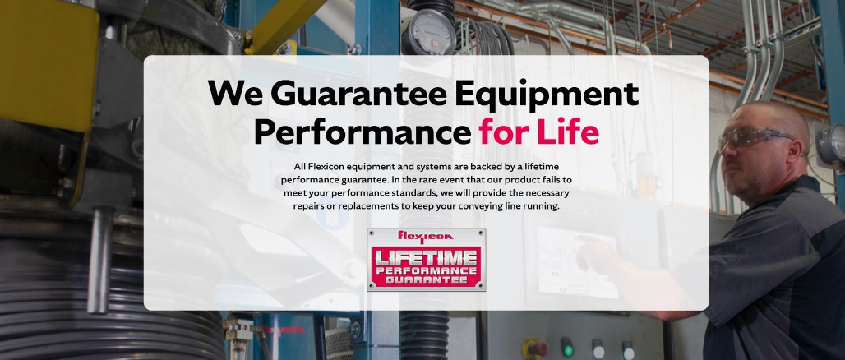

**Lifetime Performance Guarantee**

All Flexicon equipment and systems are backed by a lifetime performance guarantee. In the rare event that our product fails to meet your performance standards, we will provide the necessary repairs or replacements to keep your conveying line running.

**SHELF #4: CASE STUDIES**

